The College of Dental Surgeons of Hong Kong | 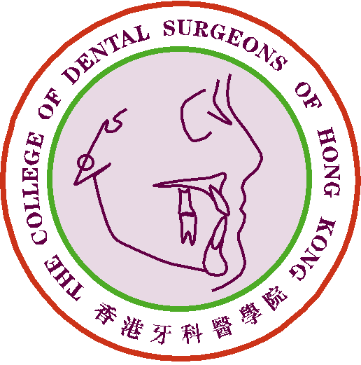
Claim Form for CME/CPD Programme

Personal Data |  | Date of Submission :
Name of Applicant : |  | Phone No.:
Email address: |  | Fax No.:

Please ☑ one only :
1) Fellow or Specialist |  |  | 2) MGD Holder |  |  | 3) Specialist Trainee

CDSHK Reply Form No.: (if applicable)

Participation in Formal College Approved Activity (FCAA)
Name of Meeting:
Meeting Date(s): |  |  |  |  |  | Total no. of Hour(s) Attended:
Venue:
Organizing Institute :
Speaker(s):
(if applicable/known)
Certificate of Attendance: |  |  |  | Certificate of Appreciation: |  |  |  |  |  | Proof of Attendance: |  |  |  |  | 
No. of Hour(s) claimed as being:  (Please select the appropriate item) |  | Attendee: |  |  |  |  |  | *Chairperson:
 |  | *Hands-on Trainer |  |  |  |  |  | *Speaker:
Nature & Duration of Meeting |  | Lecture : |  |  | Hour(s) |  |  | Workshop: |  |  |  | Hour(s)
 |  |  |  | Supporting documents attached : |  |  |  |  |  |  |  |  |  | page(s)
The following document(s) is/are required to substantiate the claim(s) in the application:
<*> | As Speaker / Chairperson / Hands-on Trainer – Invitation or Confirmation Letter to state the duration / title of presentation / date of event etc.
<*> | As Participant - Full set of program run-down of the Overseas Meeting(s) / Conference(s) has to be submitted.

For Official Use Only | Points Awarded:
For Official Use Only | Total | CME point(s)

- The CME Subcommittee has the rights to evaluate, approve, review and revise the CME point(s) for the above activity/activities.
- Please send this form and other supporting documents by e-mail to cme_cpd@cdshk.org for processing within 2 weeks after completion of the FCAA.
(Please make photocopies of these forms whenever applicable or download from
CDSHK website under “Forms Download”: http://www.cdshk.org/Forms/index.htm)

